Nama: Arrijal Mutaqin

NPM: 0620101016

**Link**

<https://github.com/ArrijalMutaqin/Pemograman-IV>

**Hasil**

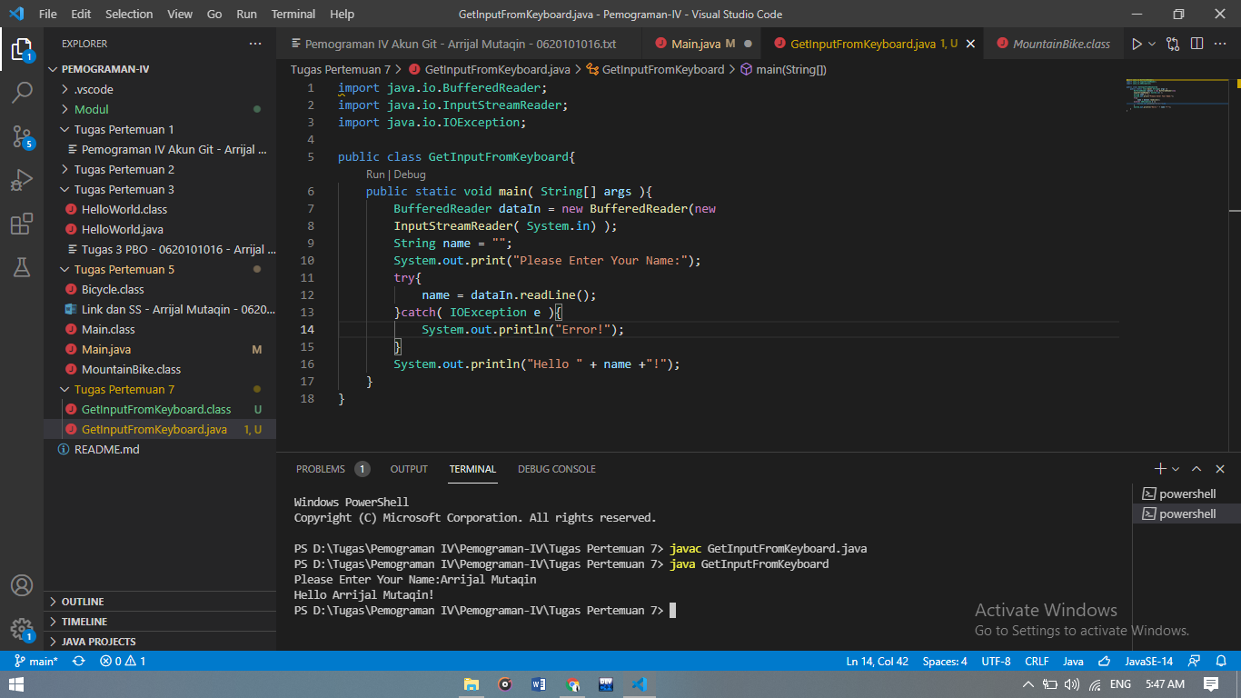

**Koding**

